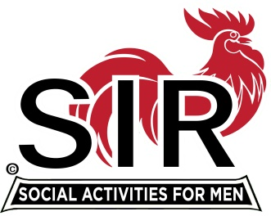
Las Trampas Branch 116
BEC Meeting Agenda
March 21st, 2022, 9:30 AM at Boundary Oaks

The Mission of SIR is to enhance the lives of our members through fun activities, events and luncheons – while making friends for life.

9:30 am Call to order; Secretary, Paul Ramacciotti, confirm a quorum and Approval of Feb 21st, 2022 BEC meeting minutes
9:35 Today’s BEC Focus – Fred Wachowicz (Welcoming our membership BACK!)
Treasurer - Alan Fitzgerald – Report and any updates to 2022 budget
9:40 Standing Reports
- Membership – Phil Goff (current count and membership confirmation issue)
- RAMP Department Head Reports:
- Recruitment, Don Schroeder
- Activity Coordinator Alex Lutkus standing in for Mike Ward
- Member Relations David Harris (seating plan)
- Publicity Al Farbman
- Covid Compliance - Kevin Donahue (Review Vax card and waiver process for today’s meeting?)

9:55 Old Business

March Boundary Oaks Luncheon

- Approved motion: When on February 16th the County of Contra Costa Health Department lifts the requirement for indoor masking at County restaurants and dining facilities for fully vaccinated individuals, SIR Branch 116 will reconvene monthly Branch Luncheons in March as well as other scheduled Dining Out activities conducted by the Branch Dine-O-SIR Group. SIR Branch 116 will continue to comply with any and all Contra Costa County Health Department Guidelines in effect for these activities and will also continue to comply with all State SIR Organization Guidelines in effect for these activities as well as SIR Branch 116 Covid Protocols.

- Boundary Luncheon arrangements (Mike Schneider)

- Review Lunch Meeting Agenda

10:05 Little SIR Updates – Roger Craig
Speaker Update (Al Farbman and Roger Craig)
Birthday Boys
10:10 Agenda Items for a BEC Zoom Meeting (set date)

- Assessment Team: Sam Beret, Steve Bort, Roger Craig, Jim Dawe, Art Donaldson, Tom Eller, Jeff Johnson
- RSVP or Standing Reservations for Future Lunch Meetings
- Boundary Oaks Branches, Area Branches, and Overlapping Opportunities
  - Publicity
  - Activities
- Surveys: Online and Table Top
- Volunteers Needed: Publicity Assistants, D-Team Leader, Recruiting Assistants, Speaker Team Member, Member Relations Assistants

10:15 am Adjourn; For Lunch Preparations

